**Task 3B: Theme & Rulebook Questionnaire**

|  |  |
| --- | --- |
| **Team ID** | 1928 |
| **College** | KCG College Of Technology |
| **Team Leader** | Sai Santosh Tejendra Talluri |
| **e-mail** | tejatalluri02@gmail.com |
| **Date** | December 14, 2023 |

| **Question No.** | **Max. Marks** | **Marks Scored** |
| --- | --- | --- |
| Q1 | 5 |  |
| Q2 | 10 |  |
| Q3 | 5 |  |
| Q4 | 5 |  |
| Q5 | 10 |  |
| Q6 | 5 |  |
| Q7 | 10 |  |
| Q8 | 15 |  |
| Q9 | 5 |  |
| Q10 | 5 |  |
| Q11 | 10 |  |
| Q12 | 5 |  |
| Q13 | 10 |  |
| **Total** | 100 |  |

**Q1.** Briefly describe your experience in building the Lunar Scout bike.

**A1.**

Building the Lunar Scout bike was quite a journey for our team. At first, we wondered if we could really do it, but we believed we'd learn along the way. We faced a bunch of problems, both technical and interpersonal, and managing time between our passion for the project and the fear of exams taught us a lot. We learned to prioritize tasks based on deadlines and reminisced about our physics days in school. We gained confidence on ourselves, teamwork skills, and finally got a chance to prove ourselves in the core department. Despite challenges like collaboration issues and figuring out how to balance the bike, we kept going. We adjusted our viewpoints, tried every possible combination, and used online resources to fine-tune our model. The journey wasn't easy, but our commitment to improvement, driven by the desire to achieve the best results, stayed strong.

--------------------------------------------------------------------------------------------------------

**Q2.** In task 1, you were introduced to LQR controller design for a simple pendulum and asked to do mathematical modelling and LQR controller design for Rotary Inverted Pendulum. In that, you were asked to derive the equations, linearize around the equilibrium point and find the A & B matrix using the Jacobian function.

In this question, you have to choose the states for your Lunar Scout bike that you are going to design. Model the system using Euler-Lagrangian Mechanics that you learned in task 1. Linearize the system using jacobians around the equilibrium points representing your physical system. Use mathematical expressions for derivations and proper diagrams where necessary.

**A2.**

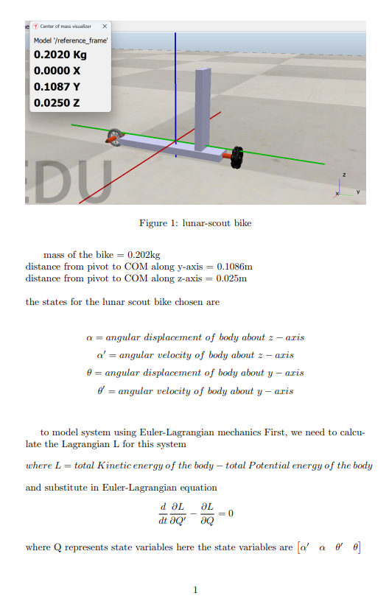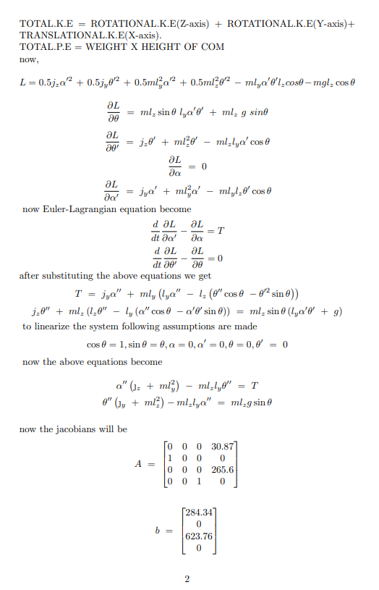

--------------------------------------------------------------------------------------------------------

**Q3.** Which is the most optimal controller between PID and LQR. Justify your answer.

**A3.**

Based on the conclusions from the research papers regarding the control of inverted pendulum and inverted pendulum-cart systems, a common trend emerges, but it's essential to consider the context and specific requirements of the Lunar Scout theme.

1. PID Controller:

- Advantages:

- Simplicity and ease of implementation.

- Satisfactory unit response characteristics.

- Effective under certain conditions and can be improved with tuning.

- Considerations:

- May lack robustness in practical scenarios.

- Performance highly dependent on tuning.

2. LQR Controller:

- Advantages:

- Optimal control decisions through the minimization of a cost function.

- Robustness and reliability demonstrated in various scenarios.

- Faster response compared to some alternatives.

- Maintains stability in the face of disturbances and model errors.

- Considerations:

- More complex to implement compared to PID.

- Requires an accurate linear model of the system.

3. Comparison:

- The LQR controller is highlighted as more robust, reliable, and faster in achieving stability compared to PID in the context of the inverted pendulum and inverted pendulum-cart systems.

- LQR outperforms PID in terms of peak overshoot and rise time according to test bed results.

4. General Justification:

- For systems with moderately complex dynamics, where an accurate linear model is available, LQR is often considered more optimal.

- PID is suitable for simpler systems but may require careful tuning and lacks the optimality achieved by LQR.

5. Consideration for Lunar Scout:

- The Lunar Scout theme involves a two-wheeled self-balancing robot navigating tracks with obstacles, making it a dynamic system with potentially complex dynamics.

- Considering the potential complexity, the robustness and optimality of LQR make it a favourable choice if the system can be adequately modelled linearly.

In summary, based on the research conclusions, the LQR controller appears to be more optimal in terms of robustness, reliability, and speed of response, especially when compared to PID.

Sources:  
Paper Title: Modelling and Control of a Rotary Inverted Pendulum Using Various Methods, Comparative Assessment and Result Analysis

Authors: Md. Akhtaruzzaman and A. A. Shafie

Paper Title: Design of Linear Quadratic Regulator for Rotary Inverted Pendulum Using LabVIEW

Authors: Kashika Chhabra, Mohd.Rihan

Paper Title: Optimal Control of Nonlinear Inverted Pendulum System Using PID Controller and LQR: Performance Analysis Without and With Disturbance Input

Authors: Lal Bahadur Prasad, Barjeev Tyagi & Hari Om Gupta

Paper Title: A comparative study for stabilizing a rotary inverted pendulum

Authors: Velchuri Sirisha and Dr. Anjali. S. Junghare

--------------------------------------------------------------------------------------------------------

**Q4.** What is the significance of finding Controllability and Observability of a system in state space approach?

**A4.**

They are Two crucial characteristics of the control system they determine systems ability to be manipulated and monitored by external inputs and outputs. They are necessary for the analysis and design of feedback controllers that can provide the stability and performance that is required.

**Controllability:**

* Controllability refers to the ability to steer or control a system's state from any initial state to any desired state within a finite time, using only the available control inputs. A matrix which determines if a system is fully controllable or not is called the controllability matrix.
* If the rank of controllability matrix is equal to number of states then the system is considered controllable.
* Understanding controllability helps in designing control strategies. If a system is uncontrollable, certain states might be impossible to reach or control, limiting the effectiveness of the designed controller.
* Controllable systems allow for more flexible and precise control over the system's behaviour.

**Observability** :

* is the property of the system that for any possible sequence of state and control inputs, the current state can be determined in finite time using only the outputs. A matrix which determines if a system is fully observable or not is called the observability matrix. A fully observable system means that it is possible to know all the state variables from the system outputs.
* If the rank of observability matrix of a system is equal to number of states in the system then system is considered observable.
* Observability aids in diagnosing faults or identifying unobservable states by analysing the system's outputs and their relationships to the internal states.
* Observability is essential for state estimation, allowing the system's internal states to be inferred or estimated based on observable outputs

Both properties are fundamental for ensuring the stability, performance, and reliability of control systems by guaranteeing the ability to control the system and accurately estimate its states.

Source: e-yantra Task1A (mathematical modelling) description.

--------------------------------------------------------------------------------------------------------

**Q5.** Briefly explain your opinion on having the centre of mass of the bike low or high. Use diagrams/calculations/examples to support your argument.

**A5.**

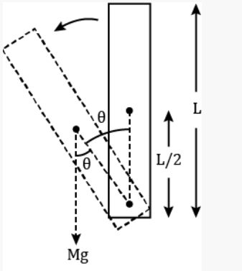

Say, the bike height be L and the centre of mass of bike lies at L/2, and mass of the bike is M.

It is evident from the free body diagram of the body that, the forces acting on body is gravitational torque only and it results in falling of the bike.

τ=Mg x L/2

**τ=MgL/2sinθ**

we also know that

τ=Iα

where I=ML^2/3 for a uniform rod (bike)

ML^2/3α = Mg[L/2sinθ]

**α=3gsinθ/2L**

the two conclusions from above derivations are

* The body will accelerate away from the vertical unstable equilibrium, and the acceleration is inversely proportional to distance between Pivot and centre of mass of body(L/2). Tall bodies fall more slowly than short ones.
* The net torque acting on body is directly proportional to distance between Pivot and centre of mass of body(L/2). The torque on tall bodies is larger compared to smaller bodies.

We can restore the bike to unstable equilibrium by providing opposite torque to body, so that the provided torque would cancel the gravitational torque and provide some acceleration in opposite side towards the unstable equilibrium position.

So basically there maybe constraints in providing restore torque if the bike is too tall and also it is difficult to control a body which is falling too quick that is shorter bodies.

So we concluded that the bike COM should be low enough to be able to provide restoring torque easily and high enough to be able to slowdown the fall

source: https://www.toppr.com/ask/question/a-uniform-rod-of-mass-m-and-length-l-is-pivoted-at-one-end-such-16/

--------------------------------------------------------------------------------------------------------

**Q6.** In what cases will the run time be considered as the maximum time (Tmax = 300 seconds) according to the scoring formula and theme rules?

**A6.**

1. If the 5-second buzzer beep occur without reaching the SL location and/or without covering all designated CS, the run time will be deemed as the maximum time allowed (300 seconds).
2. The count of Manual Interventions (MI) during the run ranges from 0 to 5. If a 6th MI is required, the run will be terminated with the time set as the maximum (T=Tmax).

--------------------------------------------------------------------------------------------------------

**Q7.** Explain what you have understood from the Theme play in your own words.

**A7.**  The Configuration Table outlines the starting location (SL), designated Colony Sites (CS) to visit, and obstacles to navigate. The Requirement Table, kept undisclosed until the run, provides details about the magnetic polarities at each CS, with expectations for LED indications based on detected polarities. The bike must start from a designated Start/Stop Location, balancing on its own with two points of contact.

During the run, the team member initiates the bike at the SL, controlling it using a team-made remote. The bike, equipped with sensors, must maintain balance throughout the run, including halts for detection and indication. At each CS, the bike halts for at least 3 seconds, utilizing a current sensor to detect the magnetic polarity. LED indications and buzzer beeps communicate the results – a Red LED for damaged CS (North Polarity) and Green LED for undamaged CS (South Polarity). The bike also navigates obstacles specified in the Configuration Table.

The run commences with a 1-second buzzer beep, and upon covering all CS, the bike returns to any SL, triggering a 5-second buzzer beep to signify completion.

--------------------------------------------------------------------------------------------------------

**Q8.** What will be the SCORE in the following situation:  
**Given Run Configuration:**

Start Location: S1

Colony Sites: 1, 2, 3, 5

Obstacle: O1, O3

In the given run there are four Colony Sites(**CS**). The bike started its journey from S1. It halted near the first CS, which has the north pole of the magnet facing the track. It indicated green LED and buzzer, then started its traversal.

* Now it has reached the second CS which has no magnet in it. It doesn’t indicate any of the light and started its traversal.
* The bike crossed one obstacle and then indicated the first CS again with red led and buzzer with proper halt, then it continued forward.
* Now it reaches its final CS which is having a south pole facing towards the track and indicating green LED and buzzer beep while passing by the CS, but without halting near the CS.
* Bike then goes to the S2 position, stops and beeps the buzzer for 5 seconds. By this time 150 seconds have passed, from the start time. The bike did not have any MI/PP/HP during the run.

**A8.**

**Run Execution:**

**First CS (CS1):** Detected North polarity, indicated with a green LED and buzzer during a proper halt.

**Second CS (CS2):** No magnet in CS2, no indication, continued traversal.

**Obstacle 1 (O1):** Crossed the obstacle, no penalties incurred.

**Return to CS1:** Indicated CS1 again with a red LED and buzzer during a proper halt.

**Final CS (CS5):** South polarity, indicated with a green LED and buzzer without a halt.

**Return to Stop Location (S2):** Stopped, triggered a 5-second buzzer, and completed the run in 150 seconds.

**Scoring Parameters:**

**Colony Visit (CV):** 2 (Visited CS1, and again CS1)

**Correct Indication (CI):** 2 (Correctly indicated CS1 and CS5)

**Wrong Indication (WI):** 1 (Indicated CS1 incorrectly during the second visit)

**Manual Intervention (MI):** 0 (No manual interventions reported)

**Hit Penalty (HP):** 0 (No hit penalties reported)

**Path Penalty (PP):** 0 (No path penalties reported)

**Obstacle Bonus (OB):** 1 (Crossed one obstacle)

**Run Bonus (RB):** 0 (Run not completed without penalties)

**Design Bonus (DB):** (Not provided in the case)

**Total Score Calculation:**

TotalScore=(300−T)+(CV×75)+(CI×150)−(WI×50)−(MI×25)−(HP×20)−(PP×10)+(OB×50)+(RB×100)+DB

TotalScore=(300−150)+(2×75)+(2×150)−(1×50)−(0×25)−(0×20)−(0×10)+(1×50)+(0×100)+DB

Total Score=150+150+300−50+0+0+0+50+0+DB

***Total Score=600+DB***

**Note:** The total score depends on the Design Bonus (DB), which is subjective and not provided in the case details.

--------------------------------------------------------------------------------------------------------

**Q9.** What is Parallel and Perpendicular axis theorem? Is it required for mathematical modelling? Justify your answer with respect to the lunar scout bike.

**A9.**

**Parallel Axis Theorem:** The moment of inertia of a rigid body about any axis parallel to an axis through the center of mass is equal to the sum of the moment of inertia about the center of mass and the product of the body's mass and the square of the distance between the two parallel axes.

*I*parallel​ = *IC* ​+ *md^*2

**Perpendicular Axis Theorem:** The sum of the moments of inertia of a planar object about two perpendicular axes in the plane of the object is equal to the moment of inertia about an axis perpendicular to the plane and passing through the point of intersection of the two perpendicular axes

*IZ*=*Ix*​+*Iy*​

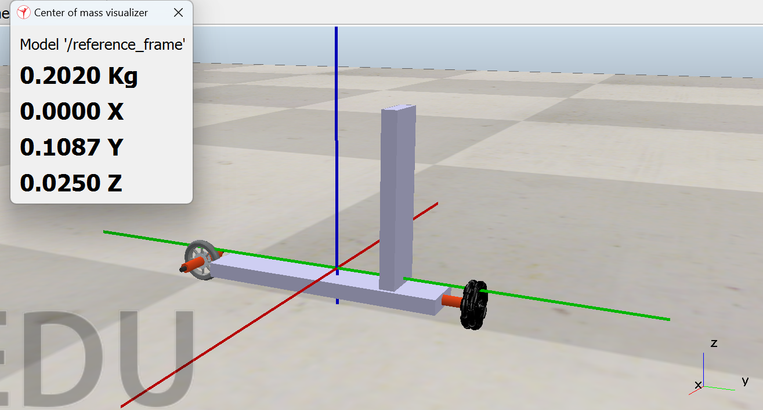

No, these theorems weren’t of use for finding moment of inertia of bike about different axes because the bike centre of mass does not lies on any part of the bike but it is situated as a point mass in space so, we considered it as point mass and found moment of inertia about different axes

--------------------------------------------------------------------------------------------------------

**Q10.** How will you check whether the system is stable or not in a state-space approach?

**A10.**

The stability of a system can be ascertained using the state-space method by examining the eigenvalues of the system matrix, which is commonly represented as A, in the state-space equations



Here

- State Vector (n x 1 matrix)

- Output Vector (p x 1 matrix)

- Input Vector (m x 1 matrix)

A - State (or system) matrix (n x n matrix)

B - Input matrix (n x m matrix)

C - Output Matrix (p x n matrix)

D - Feed-forward matrix (p x m matrix)

The system is stable if and only if all the eigenvalues of the system matrix *A* have negative real parts.

Here are the steps to check the stability of a system in a state-space approach:

* **Find the equilibrium points**
* **Calculate the jacobian of the system of equations**
* **For each equilibrium point, calculate the value of the jacobian.**
* **Construct the state equation for each equilibrium point.**
* **Find the Eigenvalues of the System Matrix *A*:**
* **Check the Real Parts of Eigenvalues:**
  + If any eigenvalue has a positive real part or is on the imaginary axis, the system is unstable or marginally stable.
  + If all the real parts of the eigenvalues are negative, the system is stable.

Source: e-yantra Task1A (mathematical modelling) description.

--------------------------------------------------------------------------------------------------------

**Q11.** What will be happening in the following situation:

The bike wrongly indicated the LED colour for a colony site while in halt. When starting to move it crosses the dotted line and hits the colony sites and falls. So Manual intervention has taken place. How many penalties will be imposed and what are they?

**A11.**

Total of 3 penalties

1. Wrong Indication (WI): 1
2. Manual Intervention (MI): 1
3. Hit Penalty (HP): 1

--------------------------------------------------------------------------------------------------------

**Q12.** How many different type sensors does a 6-axis Inertial Measurement Unit (IMU) have? Explain what physical quantities they measure exactly?

**A12.**

The 6-axis Inertial Measurement Unit (IMU) mainly comprises two sensors: the accelerometer and gyroscope. The accelerometer quantifies linear acceleration along the three perpendicular axes of X, Y, and Z. Simultaneously, the gyroscope measures angular velocity along the three perpendicular axes of X, Y, and Z. The combination of these two sensors provides information about the change in velocity and orientation over time.

--------------------------------------------------------------------------------------------------------**Q13.**  Consider a wheeled inverted pendulum having a vertical body balanced using a DC geared motor. The center of mass of the body is at 5 cm height from the axle of the wheel and motor shaft. The diameter of the wheel is 4 cm.

* What is the torque required from the DC geared motor(max RPM = 300), to be able to balance this body of total mass 1.5 kg(consider wheel & motor massless), with max correctable angular tilt as +/- 5 degrees.

(Mention steps for your calculation)

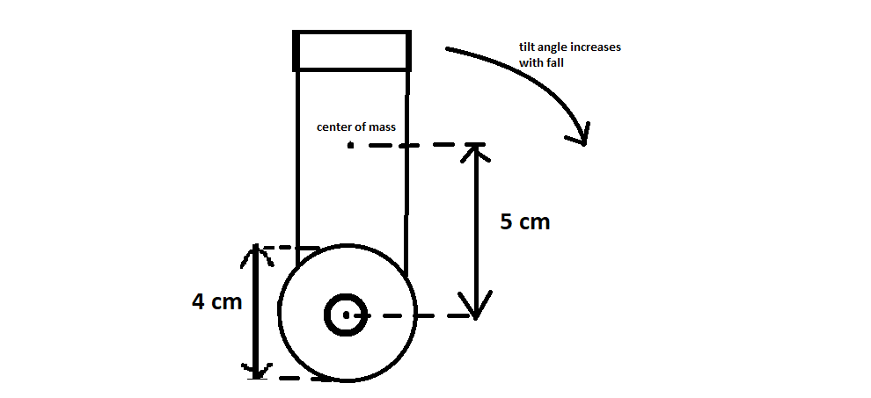

**A13.**

Balance is achieved and maintained by applying a force to the base of

the platform by moving the wheels.

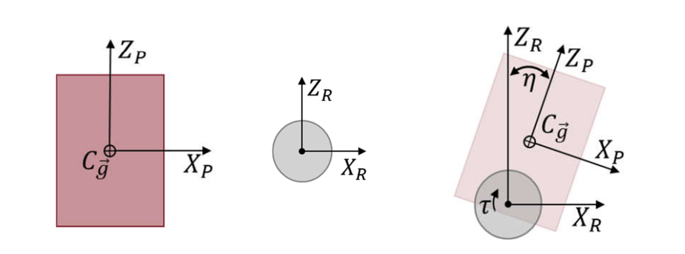

As we have given that motor max RPM = 300 then the motor able to accelerate the wheel at **0.628318 m/s^2 =** γ’’

The FBD and EFD diagrams of the body will be

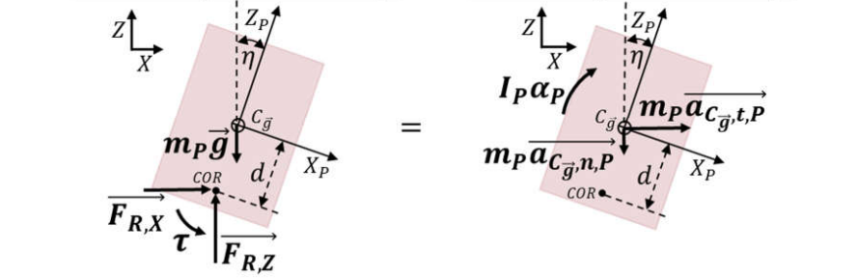

sum of the forces and moments resulted is:

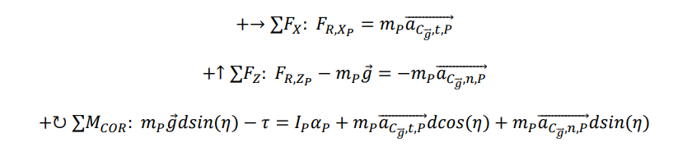

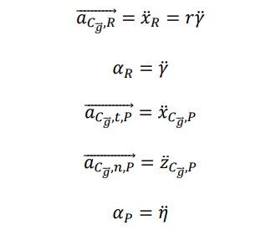

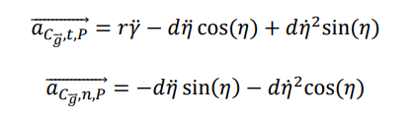

Now the above equations will be substituted



After substituting values in above equation as

**M**= 1.5 kg

**D** = 5 cm

**G**= 9.8 m/s^2

**R** = 2 cm

**γ’’** = 0.628318 m/s^2

**I** – moment of inertia assumed for cylindrical body about pivot = 12.5 kg.m^2

**η’’** = Angular acceleration of body = 25.6368 m/s^2

**the required torque = 519.1272 N-m**

source: https://scholarworks.uark.edu/cgi/viewcontent.cgi?article=1092&context=meeguht

--------------------------------------------------------------------------------------------------------